1. Hotel service load data of ship CH

* Measured every 5 sec from Feb.1.2017 to March. 31. 2017
* Unit of Y axis is kW (file: CH_Power_1702.csv, CH_Power_1703.csv)

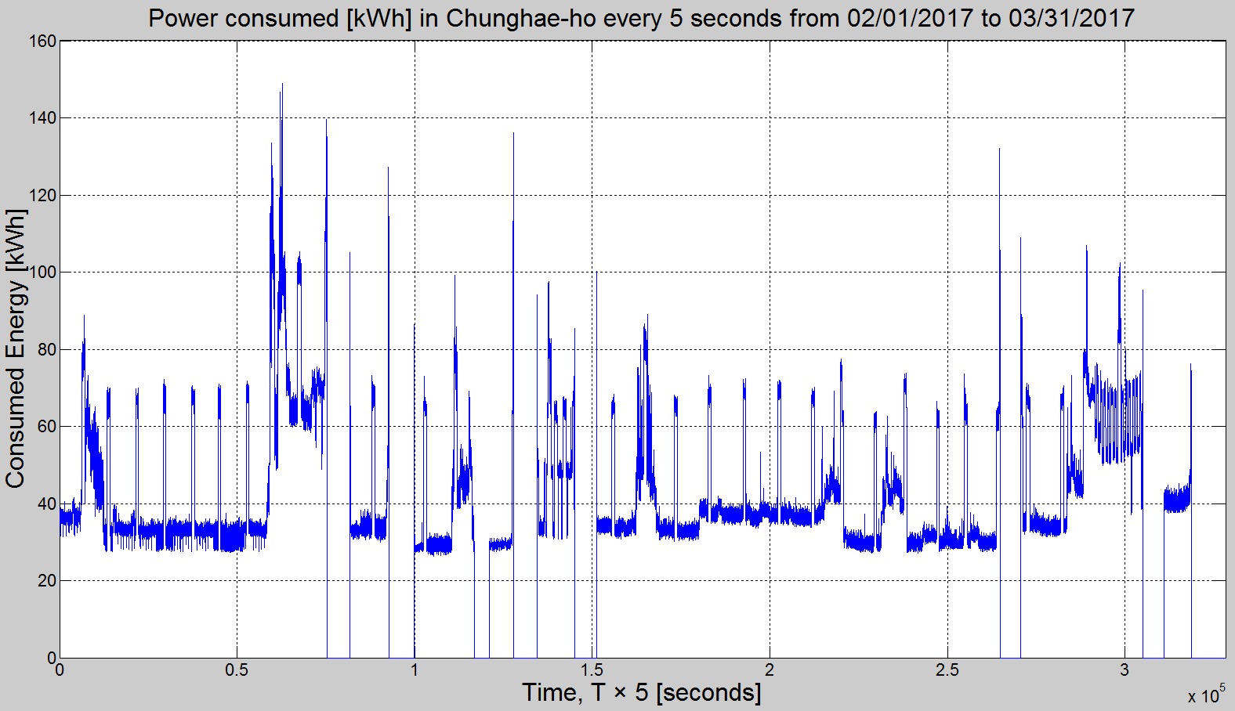

* Unit of Y axis is kWh (file: CH_Eng_1702.csv, CH_Eng_1703.csv)

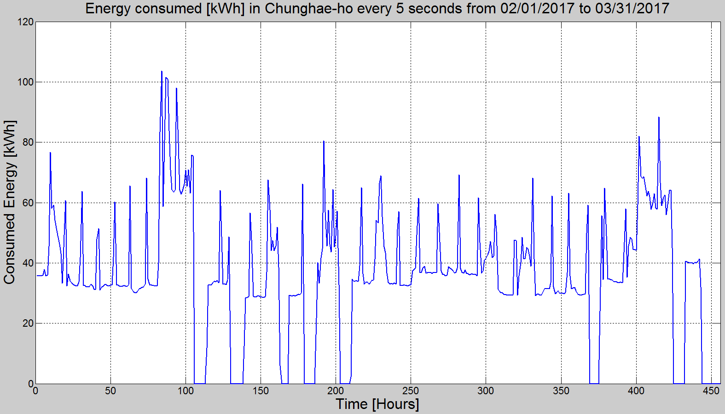

1. Hotel service load data of ship MR

* Measured every 5 sec from Feb. 1. 2017 to July 14. 2017
* Unit of Y axis is kW (file: MR_Power_1702.csv, MR_Power_1704.csv, MR_Power_1706.csv, MR_Power_1706.csv)

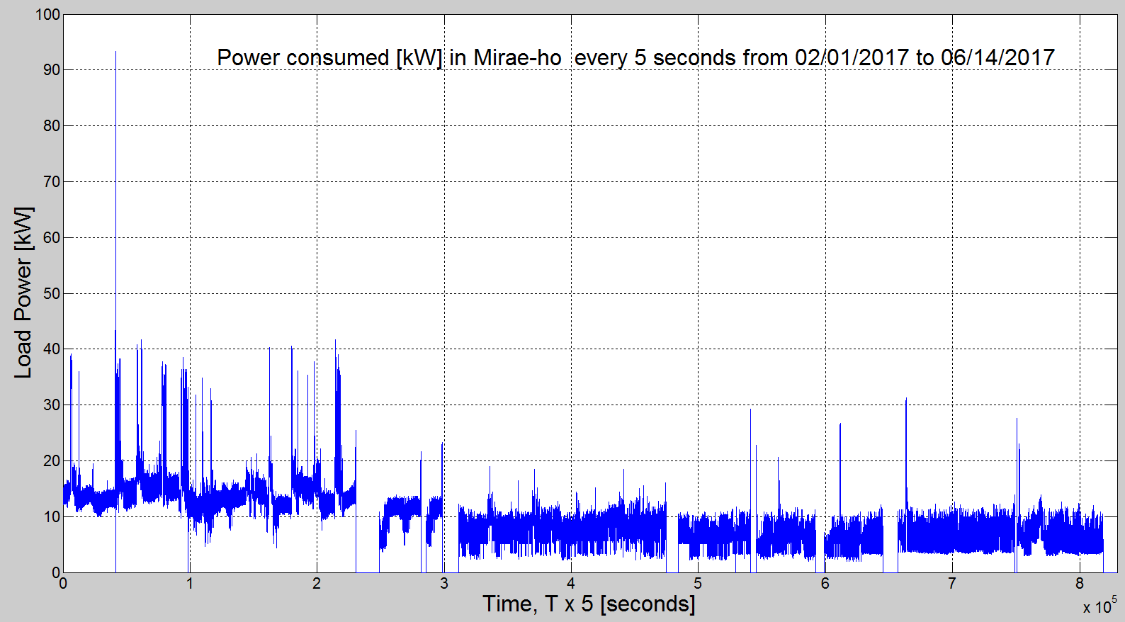

* Unit of Y axis is kWh (file: MR_Eng_1702.csv, MR_Eng_1704.csv, MR_Eng_1706.csv, MR_Eng_1706.csv)

